**Download Python:**

Visit the official Python website at <https://www.python.org/downloads/windows/> and download the latest Python installer for Windows. Choose the version that matches your system (e.g., 32-bit or 64-bit).

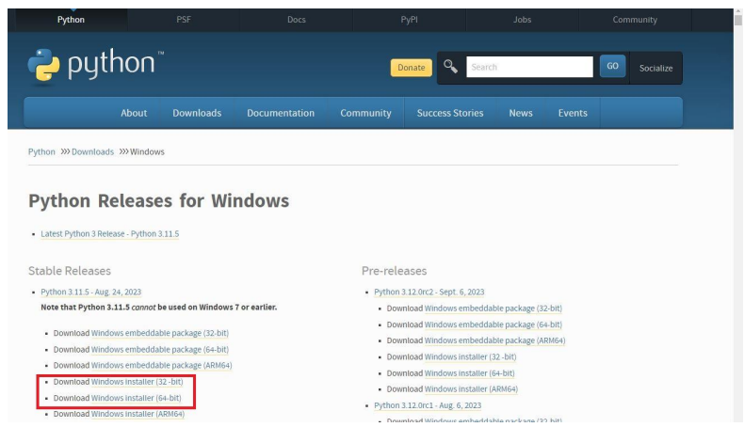

**Run the Installer:**

Double-click the downloaded installer to run it. Make sure to check the box that says "Add Python.exe to PATH" during installation. This option is essential for using Python from the command line.

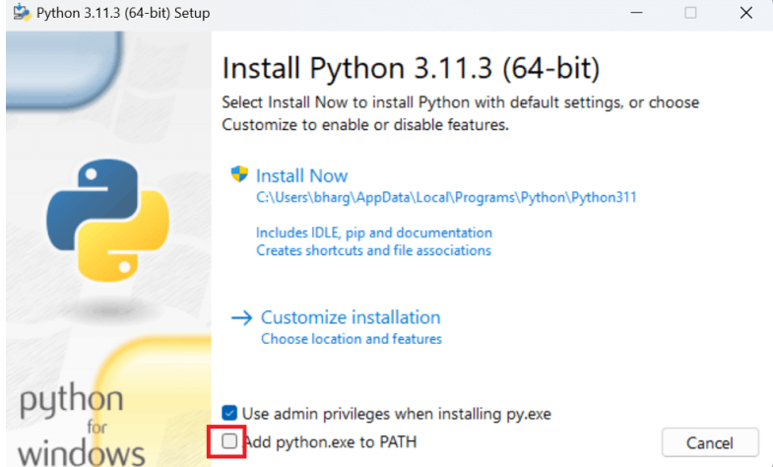

**Install Python:**

Click "Install Now" to start the installation process. Python will be installed on your system.

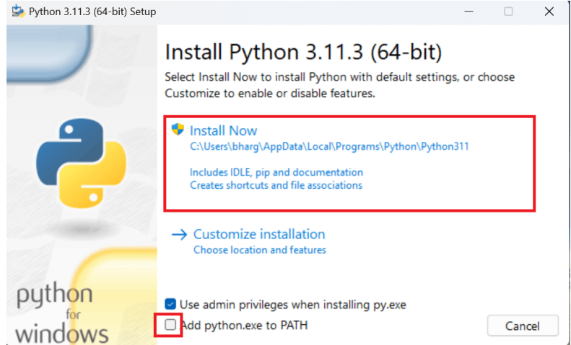

**Verify:**

To verify that Python was installed correctly, open the Command Prompt and type python --version. You should see the installed Python version displayed.

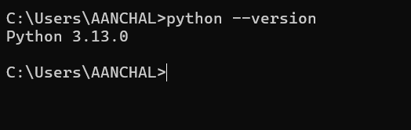

**Basic code :**

